Task 1

b)

Task 1b was a filtering operation. Computing P(Xt|e1:t), for t = 1, ..., 6.

The output was

P(Fish) P(No Fish)

X0 [0.5 0.5 ]

X1 [0.82089552 0.17910448]

X2 [0.90197069 0.09802931]

X3 [0.48518523 0.51481477]

X4 [0.81645924 0.18354076]

X5 [0.43134895 0.56865105]

X6 [0.79970863 0.20029137]

This is a filtering operation which calculate the probability of being in one state at each step given the evidence that leads up to that step.

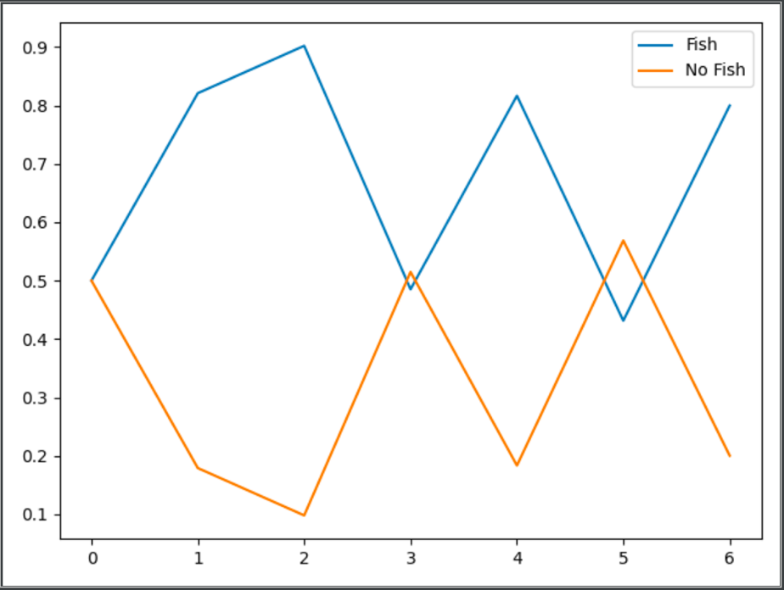

Figure 1: Graph representation of task 1b

c)

Task 1c was a prediction operation.

P(Xt|e1:6), for t = 7, ..., 30.

P(Fish) P(No Fish)

X06 [0.64992716 0.35007284]

X07 [0.62496358 0.37503642]

X08 [0.61248179 0.38751821]

X09 [0.60624089 0.39375911]

X10 [0.60312045 0.39687955]

X11 [0.60156022 0.39843978]

X12 [0.60078011 0.39921989]

X13 [0.60039006 0.39960994]

X14 [0.60019503 0.39980497]

X15 [0.60009751 0.39990249]

X16 [0.60004876 0.39995124]

X17 [0.60002438 0.39997562]

X18 [0.60001219 0.39998781]

X19 [0.60000609 0.39999391]

X20 [0.60000305 0.39999695]

X21 [0.60000152 0.39999848]

X22 [0.60000076 0.39999924]

X23 [0.60000038 0.39999962]

X24 [0.60000019 0.39999981]

X25 [0.6000001 0.3999999 ]

X26 [0.60000005 0.39999995]

X27 [0.60000002 0.39999998]

X28 [0.60000001 0.39999999]

X29 [0.60000001 0.39999999]

X30 [0.6 0.4 ]

This is a prediction operation. Based on the evidence given to the current date, the operation calculates the probabilities for future events. The probability converges towards 60% chance of fish in a nearby lake.

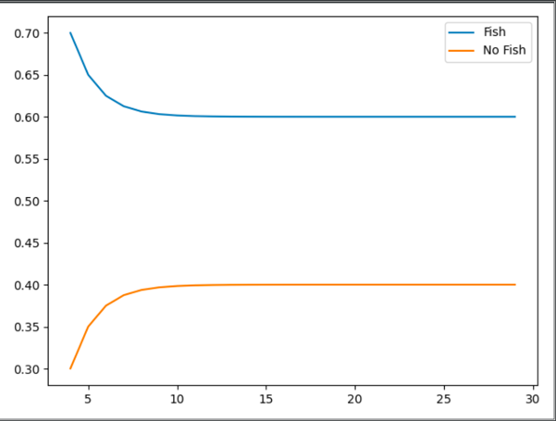

Figure 2: Graph representation of task 1c

d)

Task 1d was a smoothing operation.

P(Xt|e1:6), for t = 0, ..., 5.

P(Fish) P(No Fish)

X0 [0.66485218 0.33514782]

X1 [0.87640731 0.12359269]

X2 [0.86578657 0.13421343]

X3 [0.59792735 0.40207265]

X4 [0.76663731 0.23336269]

X5 [0.57082582 0.42917418]

A smoothing is a process of computing the distribution of earlier states given the evidence up to present. This is achieved by computing the likelihood of the evidence.

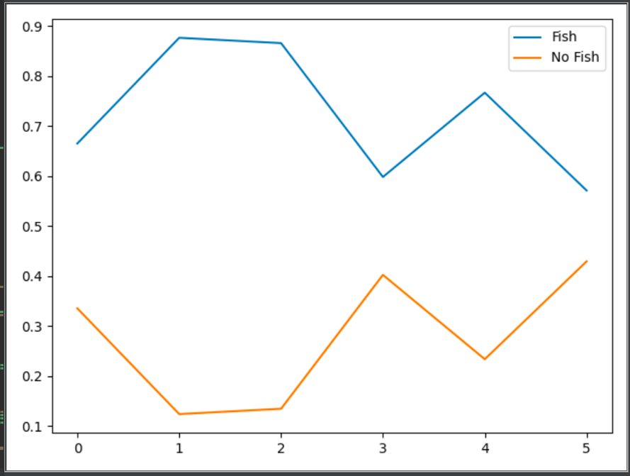

Figure 3: Graph representation of task 1d

e)

Task 1e was finding most likely path

arg max x1,...,xt−1 P(x1, ..., xt−1, Xt|e1:t), for t = 1, ..., 6.

Probability of fish/no fish Parents

P(Fish) P(No Fish)

X1 [0.82089552 0.17910448] [0. 0.]

X2 [0.49253731 0.03283582] [0. 0.]

X3 [0.09850746 0.07880597] [0. 0.]

X4 [0.05910448 0.01103284] [0. 1.]

X5 [0.0118209 0.00945672] [0. 0.]

X6 [0.00709254 0.00132394] [0. 1.]

By observing the results, the most likely path ends in X6 in Fish. The parent of this node is Fish, and parent of this is Fish… All the parents are in the left column because every previous selected node has 0 as parent.

The most likely path is therefore:

Fish – Fish – Fish – Fish – Fish – Fish

The probability of this is 0.709%.